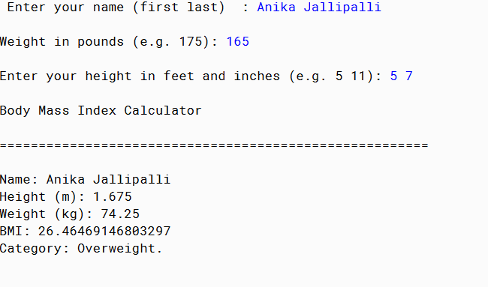

PMR: This program was good practice. The hardest part for some reason was the parsing of inches. It took my a couple hours to figure out. I had fun making this program.

/\*\*

\* The purpose of this program is to accurately and efficiently caluclate your body mass index (BMI).

\*

\* @author Anika Jallipalli

\* @version 10/8/2019

\*/

import java.util.Scanner;

public class BMI

{

public static void main(String[] args)

{

//Initialize and declare variables

String target = "";

Scanner in = new Scanner(System.in);

double BMI;

double kilograms;

double meters;

double height;

//Print program function/description

//Prompt user for input

System.out.print("Enter your name (first last) : ");

String firstName = in.next();

String lastName = in.nextLine();

System.out.println("");

System.out.print("Weight in pounds (e.g. 175): ");

String weight = in.next();

System.out.println("");

System.out.print("Enter your height in feet and inches (e.g. 5 11): ");

String feet = in.next();

String inches = in.nextLine();

System.out.println("");

//Parse Strings

double feet1 = Double.parseDouble(feet);

double inches1 = Double.parseDouble(inches);

double weight1 = Double.parseDouble(weight);

//Unit Conversions

height= ((feet1\*12)+inches1);

kilograms= (weight1 \* .45);

meters= (height \* .025);

//Calculate BMI

BMI = (kilograms/(meters\*meters));

//Determine if if normal weight, overweight, or underweight

if(BMI < 18.5)

target = "Underweight.";

else if(BMI < 24.9)

target = "Normal.";

else if (BMI < 29.9)

target = "Overweight.";

else if (BMI > 29.9)

target = "Obese.";

System.out.println("Body Mass Index Calculator");

System.out.println("");

System.out.println("=======================================================");

System.out.println("");

System.out.print("Name: ");

System.out.print(firstName + lastName);

System.out.println("");

System.out.print("Height (m): ");

System.out.print(meters);

System.out.println("");

System.out.print("Weight (kg): ");

System.out.print(kilograms);

System.out.println("");

System.out.print("BMI: ");

System.out.print(BMI);

System.out.println("");

System.out.print("Category: ");

System.out.print(target);

} //end main

}//end class